COVID 19 Contact Tracing and Notification

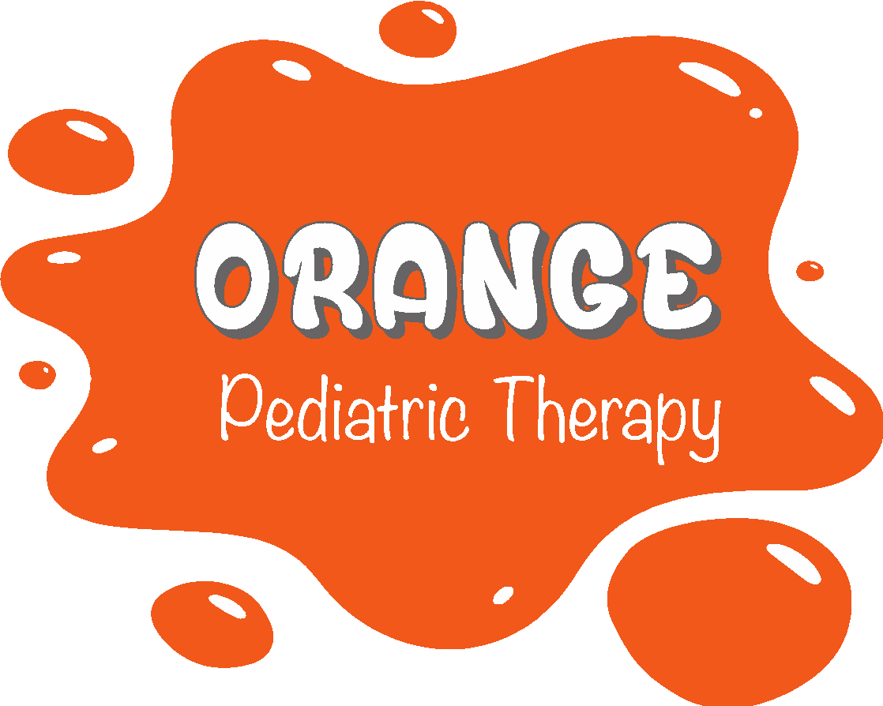
Notification of potential exposure to COVID-19

It has come to our attention that someone your child has had close contact within the past 48 hours has been diagnosed with COVID 19. Orange Pediatric Therapy uses the current CDC definition of “close contact”; any contact within 6 feet for
more than 15 continuous minutes.

Please contact your child’s pediatrician immediately to request guidance moving forward.

Date Notification Given:_____________________
Date of Potential Exposure:___________________

*OPT policy changes with the CDC guidelines and all information from the CDC should be considered the most current. Any advice given by an employee’s medical
doctor supersedes the general recommendations. *

